POWERBI + SQL Report for Pizza Hut

KPI’s

- Total Revenue
SELECT SUM(total_price) AS Toal_Revenue from pizza_sales;
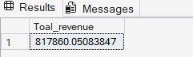

- Average Order Value
SELECT SUM(total_price) / COUNT(DISTINCT order_id) AS Average_Order_Value from pizza_sales

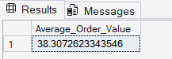

- Total Pizzas Sold
SELECT SUM(quantity) AS Total_Pizzas_Sold from pizza_sales

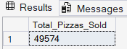

- Total Orders
SELECT COUNT(Distinct order_id) AS Total_Orders from pizza_sales

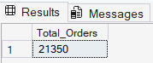
- Average Pizzas Per Order
SELECT SUM(quantity) / COUNT(Distinct order_id) AS Average_Pizzas_per_order from pizza_sales

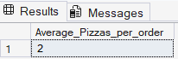

- Daily trend for total orders
SELECT DATENAME (DW, order_date) as Order_day, COUNT(DISTINCT order_id) as Total_Orders from pizza_sales
GROUP BY DATENAME (DW, order_date)

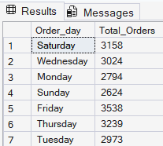

- Monthly trend for total orders
SELECT DATENAME (MONTH, order_date) as Month, COUNT(DISTINCT order_id) as Total_Orders from pizza_sales
GROUP BY DATENAME (MONTH, order_date)

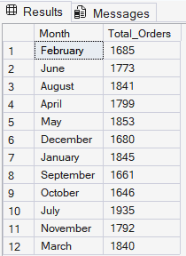

- Percentage of sales by catergory
SELECT pizza_category, SUM(total_price) * 100 / (SELECT SUM(total_price) from pizza_sales) AS Monthly_Sales_Percentage
from pizza_sales
GROUP BY pizza_category

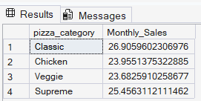

- Percentage of sales by size
SELECT pizza_size, CAST(SUM(total_price) * 100 / (SELECT SUM(total_price) from pizza_sales) AS DECIMAL(10,2)) AS Monthly_Sales_Percentage
from pizza_sales
GROUP BY pizza_size
ORDER BY Monthly_Sales_Percentage ASC

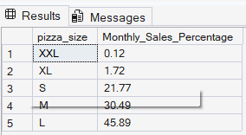

- Top 5 best sellers

- By Revenue:
SELECT TOP 5 pizza_name, SUM(total_price) AS Total_Sales
from pizza_sales
GROUP BY pizza_name
ORDER BY Total_Sales DESC
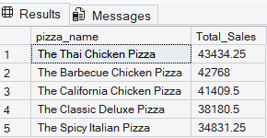

- By Quantity:
SELECT TOP 5 pizza_name, SUM(quantity) AS Total_Orders
from pizza_sales
GROUP BY pizza_name
ORDER BY Total_Orders DESC

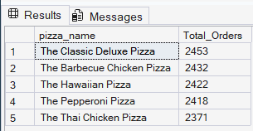

- By Orders:
SELECT TOP 5 pizza_name, COUNT(DISTINCT order_id) AS Total_Orders
from pizza_sales
GROUP BY pizza_name
ORDER BY Total_Orders DESC

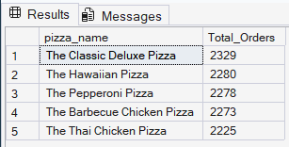

- WORST 5 sellers

            - Revenue:
SELECT TOP 5 pizza_name, SUM(total_price) AS Total_Sales
from pizza_sales
GROUP BY pizza_name
ORDER BY Total_Sales
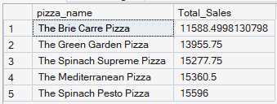

- By Quantity:
SELECT TOP 5 pizza_name, SUM(quantity) AS Total_Orders
from pizza_sales
GROUP BY pizza_name
ORDER BY Total_Orders

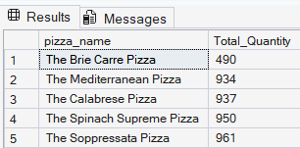

- By Order:
SELECT TOP 5 pizza_name, COUNT(DISTINCT order_id) AS Total_Orders
from pizza_sales
GROUP BY pizza_name
ORDER BY Total_Orders

